Alumni Recommendation System Using K-Nearest Neighbors (KNN)
This document outlines a step-by-step algorithm to recommend alumni profiles based on a selected profile using the K-Nearest Neighbors (KNN) approach. The algorithm takes into account various input features such as name, age, gender, company, profession, and experience.
The focus will be on data preprocessing, feature encoding, distance calculation, and top-N recommendations.
Additionally, optional improvements using Deep Neural Networks (DNN) and user feedback integration will be discussed.

System Overview
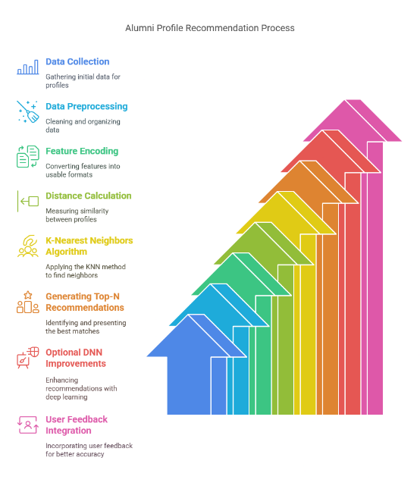

📊 1. Data Collection
Collect alumni data that includes the following features:
- Name
- Age
- Gender
- Company Name
- Working Profession
- Experience (in Years)
This dataset should be cleaned and organized in a structured tabular format (e.g., CSV).
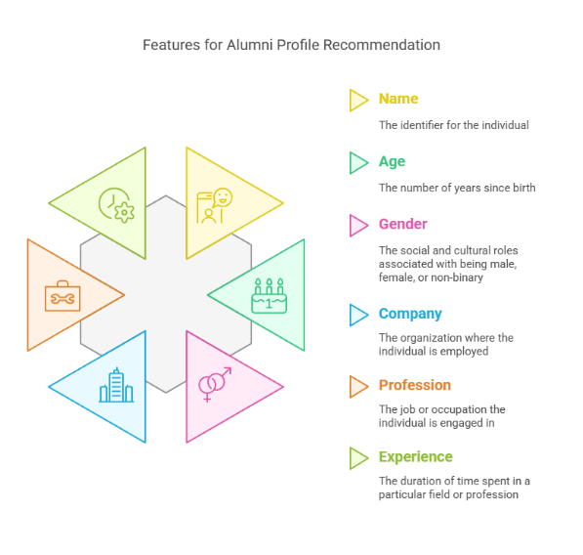

Example Dataset

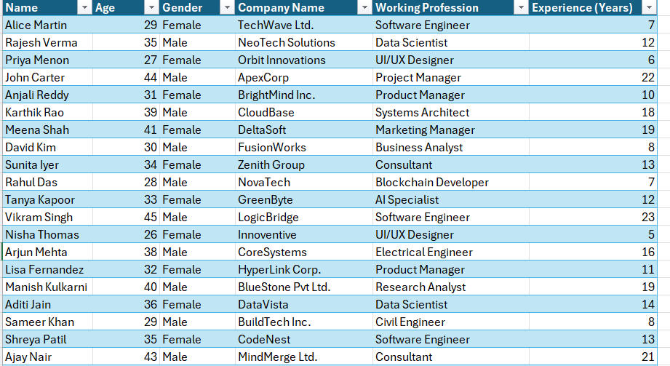

📐 2. Distance Function
To find similar profiles, implement a distance function (like Euclidean or cosine similarity) based on the encoded features:
- Convert categorical variables (Gender, Company, Profession) using Label Encoding or One-Hot Encoding
- Normalize numerical features (Age, Experience)
The distance between two alumni profiles AAA and BBB with feature vectors a⃗\vec{a}a and b⃗\vec{b}b is calculated using:
Distance(A,B)=∑i=1n(ai−bi)2\text{Distance}(A, B) = \sqrt{\sum_{i=1}^{n} (a_i - b_i)^2}Distance(A,B)=i=1∑n​(ai​−bi​)2​
This distance helps in identifying which profiles are "close" to the selected one in terms of experience and professional background.

Distance Calculation Illustration
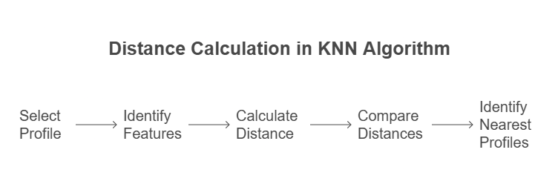

🔍 3. Selecting K and Making Recommendations
✅ Selecting K
- Choose the number of neighbors K (e.g., K=5, 10)
- Higher values of K smooth out local anomalies
- K should not be too high to avoid bias or too low to miss diversity
🔍 Finding Neighbors
- For a given selected profile, calculate distance to all other alumni profiles
- Sort them in ascending order of distance
- Filter out profiles from the same company (optional) to improve diversity
⭐ Top-N Recommendation
- From the sorted list, pick Top-N closest profiles
- Return their Name, Profession, Company, and Experience to the user
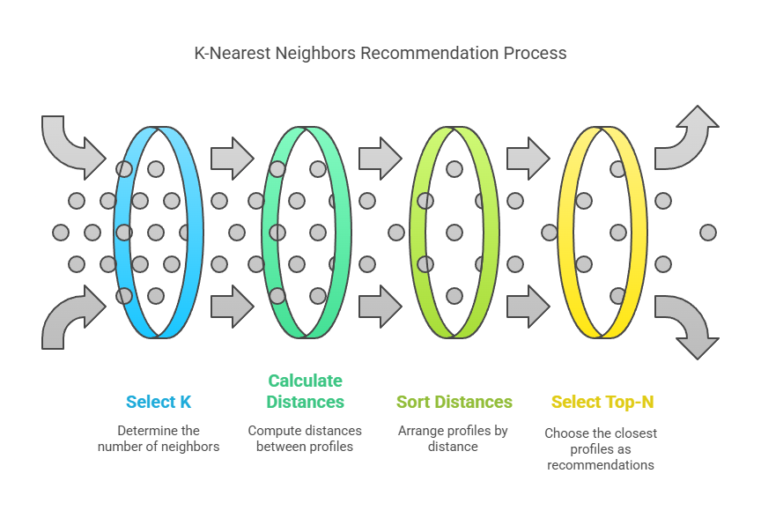

🧠 Optional Enhancements
- Use a Deep Neural Network (DNN) with embeddings to learn better feature representations
- Include feedback loops to improve recommendations based on follow/click behavior
- Apply clustering (like K-Means) to group similar alumni before recommendation

📌 Summary
- This AI agent uses KNN for personalized alumni recommendations
- Profiles are recommended based on age, experience, company, and profession similarity
- Future improvements may include deep learning, feedback learning, and recommendation diversity controls
This project, titled "AI-Based Alumni Recommendation System using K-Nearest Neighbors (KNN)", was developed and implemented by:
- P. Jeyanth (Roll No: Y23CD148)
- Sk. Mansoor Basha (Roll No: Y23CD168)
as part of their FAI Assignment . The work involves designing an AI agent to recommend alumni profiles based on user selection using machine learning techniques, particularly KNN-based similarity analysis.

